Biology 313

Discussion for the week of 9-4

16 pts

**1.** (1pt) Take a look at the brief research summary at the following site:

http://www.nih.gov/news/health/oct2013/ninds-17.htm

Then answer the following question, simply based on what the summary says (easy point):

What is the role of glial cells in sleep?

According to the description of the article, these cells clear the brain of damaging molecules associated with neurodegeneration. They do this by controlling flow throuhgh the glymphatic system by shrinking or swelling, which lets the cerebral fluid flow rapidly around the brain and clear out toxins.

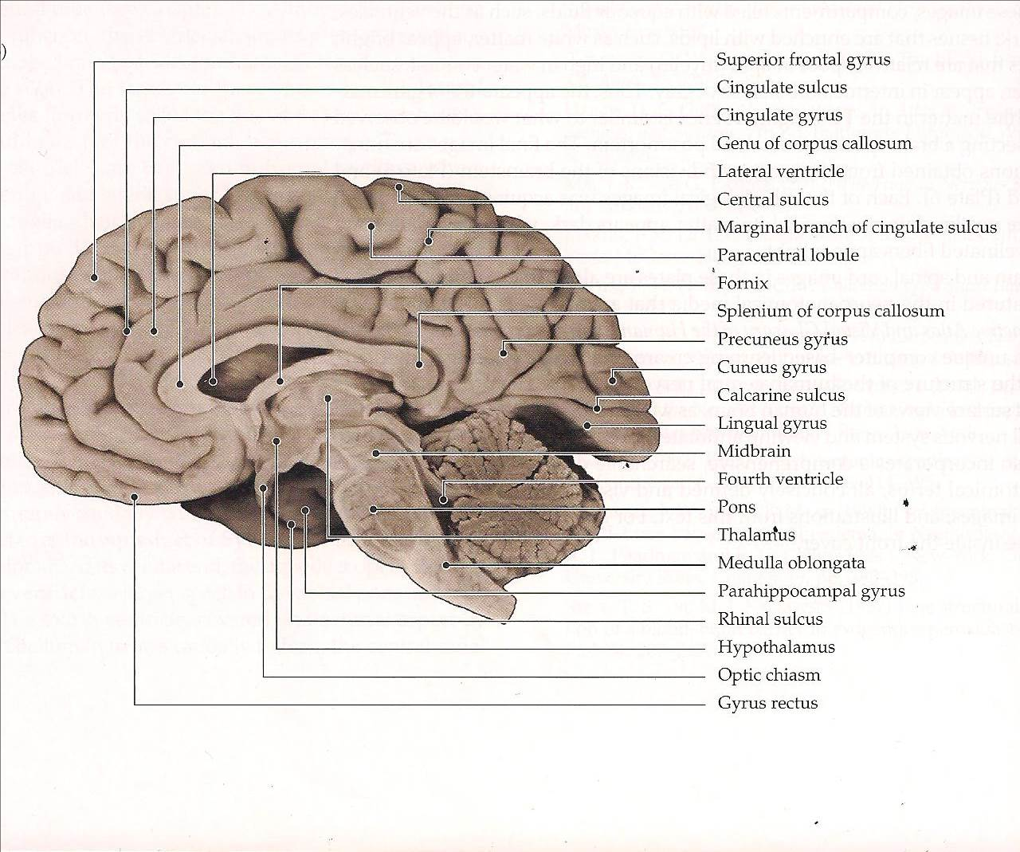

**2.** (4pts) Looking at the anatomical drawings presented here,

Using the saggital section drawing, name a structure that is:

**a.**caudal to the pons

**b.** rostral and inferior to the thalamus

**c.** posterior and inferior to the splenium of the corpus callosum

**d**. draw a circle around the frontal lobe

**Using the frontal section drawing**, name a structure that is:

**e.** medial to the thalamus

**Fornix**

**f.** ventromedial (both ventral and medial) to the internal capsule

**Mammillary body**

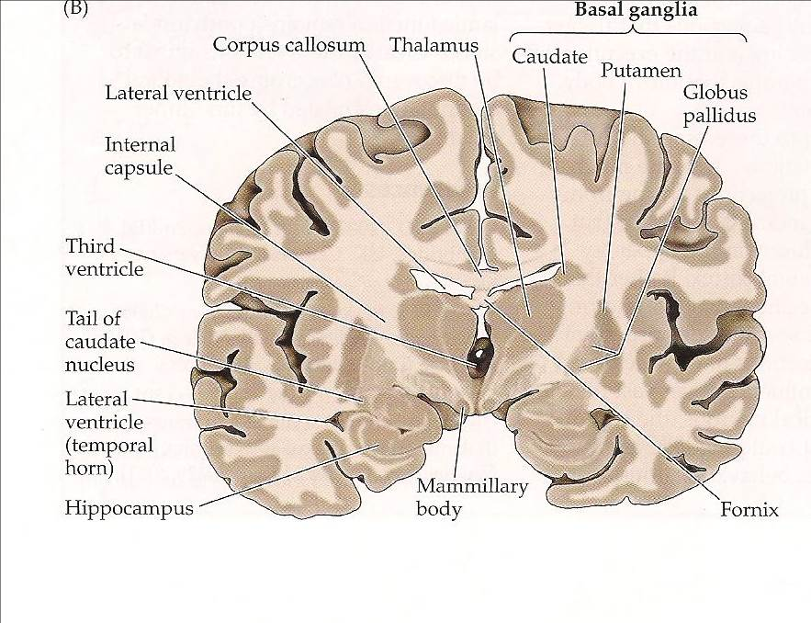**g.** dorsomedial (both dorsal and medial) to the internal capsule

**corpus callosum**

**h.** The putamen lies _______ to the thalamus

**lateral**

**3.** (1pt)With cerebellar damage, the patellar stretch reflex isn’t a single jerk, but leg swings thru several cycles. Why do you think this happens?:

The cerebellum is usually involved in muscle control and contraction, damage to the cerebellum usually leads to jerky movement. The brain is usually not involved in the reflex arc, so the continued swinging after the initial swing must be because the person is having trouble stopping their leg from swinging due to the damaged cerebellum.

**4.**(10pts) A number of drugs act on the autonomic nervous system:

**a.** Acetylcholinesterase inhibitors block the activity of the enzyme that destroys acetylcholine. They are sometimes prescribed for people with Alzheimer’s diseases. One of the undesirable side effects of acetylcholinesterase inhibitors is over activity of the gut and diarrhea.

Does this drug act on the sympathetic or parasympathetic nervous system?

Parasympathetic nervous system mainly.

Why this would be an expected side effect?

In the parasympathetic system, ACH is used in both pre-ganglionic and post-ganglionic neurons, but in the sympathetic system it is only used pre-ganglionic.

**b.** beta-blockers are drugs that block receptors for adrenaline. What division of the autonomic nervous system do they act upon?

The sympathetic nervous system.

They are sometimes prescribed for heart patients. What this drug would do for the heart?

It would reduce HR.

**c.** The belladonna drug atropine was once used to make ladies beautiful by blocking the acetylcholine receptors in the eye. Does this drug act on the sympathetic or parasympathetic nervous system?

Parasympathetic

What would be the effect of applying this drug to an eye?

It would block parasympathetic neurotransmitters. It would dilate the eye.

**d.** Propranolol is used to treat irregular heart rates and high blood pressure. It can have a side effect of alleviating anxiety (which some people apparently really enjoy!).

Does this drug act on the sympathetic or parasympathetic nervous system?

This drug, assuming it is a blocker, acts on the sympathetic nervous system by blocking receptors.

What does it do when it binds to a receptor on the heart?

It blocks these receptors without activating them to prevent norepinephrine or other neurotransmitters from binding.

**e.** Pilocarpine is sometimes used to treat dry mouth (a lack of saliva). Does this drug act on the sympathetic or parasympathetic nervous system?

This drug acts on the parasympathetic nervous system

It activates what kind of receptor?

Muscarinic acetylcholine receptor, the parasympathetic system uses Ach neurotransmitters pre and post ganglionic